



ESG Reporting Best Practices: Driving Business Success Through Sustainability

## Mateusz Panek, PhD, DBA, LLD, LLM, MBA

Supply Chain Analytics Practice Lingaro Group



ESG reporting involves the disclosure of a company's performance in environmental, social, and governance aspects and allows stakeholders to assess its sustainability efforts. The rising importance of ESG reporting for companies is a direct response to the increasing demand from stakeholders and consumers for greater transparency and accountability in their business practices and operations.

Case in point: Approximately 76%1 of consumers explicitly stated that they would cease their purchases from companies that engage in negative practices toward

the environment, employees, or the local community. Moreover, a survey2 encompassing consumers, employees, and executives revealed that both consumers and employees expect businesses to proactively establish ESG best practices rather than merely reacting to them.

It is crucial for companies to go beyond reactive measures and integrate sustainability initiatives into their core values and organizational structure. This integration entails aligning these initiatives with the company's foundation and purpose while ensuring transparent measurement and reporting, which is where ESG reporting plays a pivotal role.

In this white paper, we’ll delve into industry best practices and guidelines as well as mandated requirements for

ESG reporting, and how organizations can use data and analytics to move sustainability efforts forward and bolster their credibility.

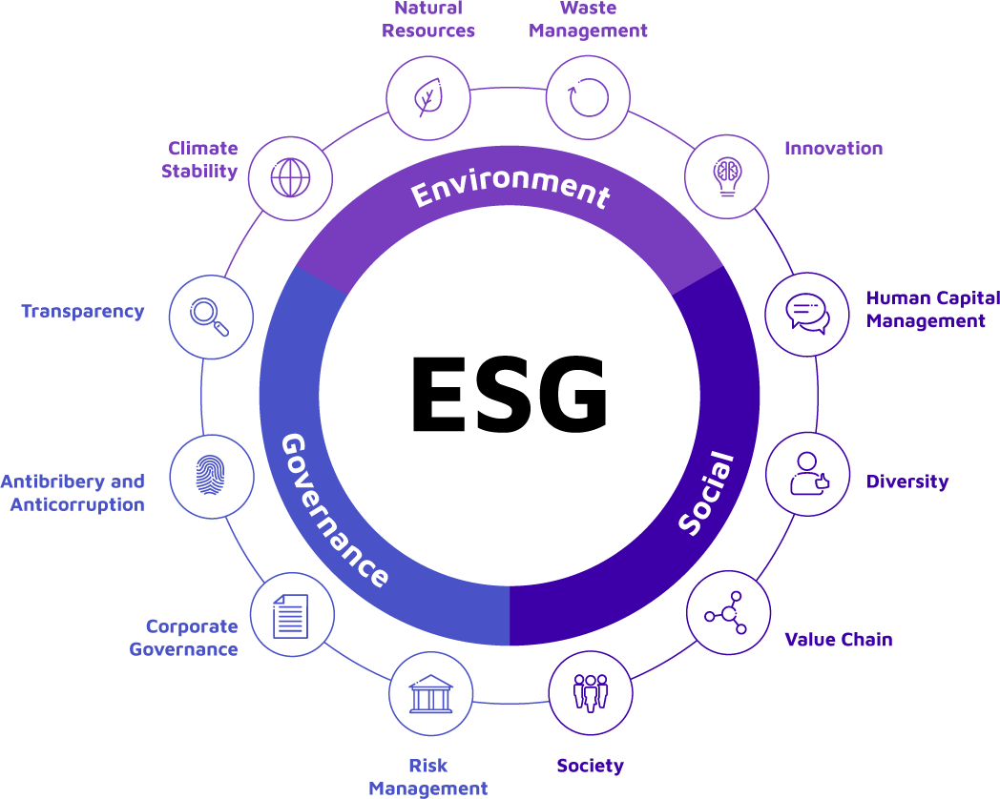

Figure 1. The different aspects of the environmental, social, and governance (ESG) framework/approach/standard.

ESG reporting enables businesses to communicate environmental, social, and governance performance to stakeholders such as investors, customers, employees, and communities. ESG reporting typically involves disclosing information on a wide range of ESG issues, such as:



**Making Sense of Carbon Offsetting: Opportunities and Challenges for Businesses**

**ESG Reporting Fundamentals**

* **Environmental.** This includes information on

a company's impact on the environment, such as greenhouse gas (GHG) emissions, water usage, waste generation, and resource consumption.

* **Social.** This includes information on a company's impact on society, such as labor practices, human rights, employee diversity and inclusion, community engagement, and product safety.
* **Governance.** This includes information on

a company's governance structure and practices,

such as board composition, executive compensation, risk management, and anticorruption policies.

ESG reporting has a strategic advantage for enterprises.

Companies that possess robust ESG propositions have surpassed their counterparts in terms of total shareholder return by an average of 4.7 percent.

Furthermore, companies with strong ESG propositions have experienced an average increase of 19% in their valuation multiples, whereas those with weak ESG propositions have witnessed an average decline of 12% in their multiples.3

Valuation multiples are ratios that compare the value of a company to some measure of its performance, such as earnings, sales, or book value. They are used to estimate how much a company is worth relative to

other similar companies in the same industry or market.

It's crucial to establish a clear ESG framework that outlines what will be reported and how it will be measured. Aligning ESG reporting with standardized best practices or guidelines as well as mandated requirements enhance comparability between companies, facilitate benchmarking, and drive industrywide improvements in sustainability practices.



**Making Sense of Carbon Offsetting: Opportunities and Challenges for Businesses**

**Best Practices in ESG Reporting**

Here are some best practices for establishing a strong ESG framework:

# Identify the audience and stakeholders.

To ensure that the ESG report meets the needs of its stakeholders, a company should identify and track stakeholder engagement. This can involve activities such as outreach, surveys, interviews, and media monitoring. By engaging with stakeholders, the company can identify new ESG issues and address existing or future ones.

For instance, the Global Reporting Initiative (GRI) defines stakeholders as individuals or organizations that are affected by, or can affect, the company's ESG initiatives. These can include customers, employees, investors, suppliers, regulators, nongovernment organizations (NGOs), and communities.

Stakeholder engagement should be an ongoing process, as the needs and priorities of stakeholders can change over time. By tracking stakeholder engagement,

a company can ensure that its ESG report remains relevant and useful to its stakeholders. This can also help identify areas where it can improve its ESG performance and reporting.

# Establish a clear ESG framework.

Credible ESG reporting involves the disclosure of accurate and comparable information. A robust ESG framework involves:

**Dgfining ESG mgtrics snd KPIs**. These success factors should be relevant to the business, aligned

with business objectives, and easily measurable. For example, a technology company may track energy consumption, waste generation, and employee diversity as ESG metrics, with corresponding KPIs such as reducing energy consumption by 10% over the next

five years and increasing the proportion of women in leadership positions to 30% by 2025.

Companies can also use established standards and frameworks, such as the GRI, Sustainability Accounting Standards Board (SASB), and the Task Force on Climate- related Financial Disclosures (TCFD). These frameworks can provide you guidance on which ESG issues to prioritize and how to measure and report on them.

**Setting ESG targets.** They should be relevant and aligned with industry standards and best practices. For example, companies can set a target to reduce its GHG emissions by 30% by 2030, in line with the Paris Agreement targets.

**Collecting and managing data.** This data needs to be:

* **Relevant and reliable.** Identify the data sources for each ESG metric and KPI and establish processes

to collect and manage the data. This could involve working with third-party providers or investing in specialized software to automate data collection and analysis. Furthermore, different ESG reporting standards have their own specific data requirements that reflect their objectives and focus areas. For instance, the TCFD focuses on climate-related risks and opportunities, while SASB aims to provide industry-specific standards that prioritize financially material sustainability.

* **High-quality and accurate.** Establish data quality controls, such as regular data cleaning and verification, as well as data governance frameworks to ensure data privacy, security, and compliance.

**Reporting and communicating progress.** This entails:



**Making Sense of Carbon Offsetting: Opportunities and Challenges for Businesses**

* + **Choosing appropriate reporting platforms.** There are several types of reporting platforms for ESG, including standalone reports, integrated reports, sustainability reports, and disclosures within annual reports. Each type of report has its own advantages and disadvantages, and the choice of reporting platform should be informed by various factors.
  + **Creating clear and concise ESG reports.** ESG reports should be structured and formatted in a way that is easy to understand and follow, with a clear summary of the most important findings and trends. ESG reports should also include both quantitative and qualitative information, including case studies, best practices, and stakeholder feedback.
  + **Ensuring transparency and disclosure.** Reports need to be open and honest about ESG performance, including any challenges or limitations that might affect performance. ESG reports should include relevant contextual information, such as performance benchmarks, industry trends, and regulatory developments to provide a comprehensive and balanced view of ESG performance.

**Reviewing policies and industry practices regularly.** This includes assessing whether ESG metrics and KPIs are still aligned with business objectives and industry standards as well as identifying any emerging ESG issues that may require additional attention

or resources.

ESG reporting is a rapidly evolving field, and businesses need to stay up to date with industry practices and trends to ensure that they are meeting stakeholder expectations and regulatory requirements. This includes tracking developments in reporting frameworks, such as the GRI and SASB, as well as following industry-specific initiatives and standards, such as the Equator Principles for the finance sector or the Fashion Industry Charter for Climate Action.

Materiality refers to the significance, relevance, and impact of a particular issue to a company's business and its stakeholders. Its importance in ESG reporting owes to. There are several reasons.4,5,6,7



**Making Sense of Carbon Offsetting: Opportunities and Challenges for Businesses**

**Materiality in ESG Reporting**

1. **Relevance to stakeholders:** Materiality ensures that organizations report on ESG issues that matter most to their stakeholders, such as investors, customers, employees, regulators, and the local community. It helps identify and prioritize the ESG topics that have the greatest potential to affect business performance and stakeholder trust.
2. **Risk management:** Identifying material ESG issues allows organizations to understand and manage potential risks associated with these issues. By reporting on material risks and their mitigation strategies, companies can enhance their resilience, minimize negative impacts, and protect their long- term viability.
3. **Decision-making:** Materiality provides decision- makers with reliable information about a company's ESG performance, allowing for comparisons across companies and industries.
4. **Transparency and accountability:** By focusing on material issues, organizations demonstrate their

commitment to reporting information that is relevant, reliable, and useful.

1. **Efficigncy snd rgsourcg sllocstion.** By identifying and prioritizing material ESG issues, organizations can allocate resources to address those with the most significant impact, set meaningful targets, and implement effective sustainability initiatives.

# Double materiality

Traditionally, corporate reporting focused primarily on financial performance and risks that directly affect the company’s bottom line. With the growing the broader impact and dependencies of businesses on

the environment and society, however, the concept of double materiality has gained prominence.

Double materiality is a concept in sustainability and corporate reporting that recognizes the importance of assessing a company’s external impact to the environment and society (the “outward” or “first” materiality). It also acknowledges the potential risks and opportunities that environmental and social factors pose to the company (the “inward” or“second” materiality).8

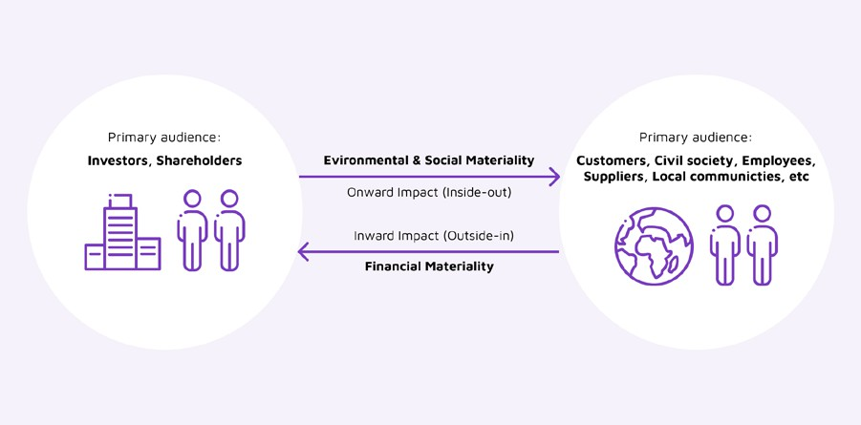

Figure 2. A visualization of double materiality.

# Best practices for managing material ESG issues



**Making Sense of Carbon Offsetting: Opportunities and Challenges for Businesses**

Double materiality acknowledges that sustainability issues can have a significant impact to a company’s long-term viability and financial performance. This includes factors such as climate change, resource scarcity, social inequality, regulatory changes, and shifting consumer preferences.

Here are a few best practices:

* **Conduct a materiality assessment.** This assessment should consider internal and external perspectives and account for the potential impact to the company’s financial performance and reputation.9
* **Prioritize material issues.** Once the material ESG issues have been identified, companies should prioritize them based on their significance and the level of risk they pose to the business. This prioritization should inform the company's ESG strategy, policies, and initiatives.
* **Engage with stakeholders.** Companies should engage with their stakeholders regularly to understand their perspectives on the material ESG issues and ensure that their reporting is relevant and credible. This engagement should be anongoing process, and companies should seek feedback

on their reporting to continually improve their ESG practices.

Investors have always been concerned with financial returns on their investments. However, in recent years, there has been a growing trend toward socially responsible investing (SRI). The increased public attention towards critical issues such as the climate crisis and environmental sustainability has played a pivotal role in driving its popularity, particularly among younger investors.10



**Making Sense of Carbon Offsetting: Opportunities and Challenges for Businesses**

**ESG Score and Why It Matters**

By the end of 2020, US$12.2 billion11 was invested in funds specifically focused on ESG factors. In fact, experts forecast that SRI could grow into a massive

US$50-trillion12 industry within the next two decades. This has led to the development of a new metric for evaluating sustainability practices, known as the

ESG score.

# How ESG score is evaluated

ESG score evaluates ESG performance. ESG scores are calculated using a variety of factors and methodologies, depending on the ESG rating provider.13 However,

in general, ESG scores are calculated by analyzing a company’s ESG practices.

ESG rating providers evaluate these factors using various data sources, including public disclosures, regulatory filings, media reports, and other publicly available information. They then use proprietary methodology to analyze and weigh these factors to generate an ESG score.

Moreover, some ESG rating providers use a numerical system to assign a score, such as a 1-100 scale, while others use a letter-based system, such as A-F grading. The higher the score or grade, the better a company is deemed to be in terms of its ESG practices.

# ESG ratings and data providers

The demand for ESG scores led to the emergence of numerous ESG ratings and data providers, each with their own methodology and approach. The

measurement of performance and assignment of an ESG score can be done by various entities.

Here are some key stakeholders involved in measuring and assigning ESG scores:

* + **ESG rating agencies:** These are specialized organizations that evaluate companies based on their ESG performance and assign corresponding scores. Examples of prominent ESG rating agencies include Morgan Stanley Capital International (MSCI), Sustainalytics, and Institutional Shareholder Services (ISS) ESG.
  + **Financial institutions:** Many financial institutions, such as banks, asset managers, and investment firms have developed their own ESG scoring methodologies. They assess the ESG performance of companies to guide their investment decisions and allocate capital accordingly.
  + **Rgsgsrch firms:** Several research firms conduct in- depth analysis and research on ESG factors, including performance metrics and scoring methodologies. Examples include BloombergNEF and CDP (formerly the Carbon Disclosure Project).
  + **Stock exchange:** Some stock exchanges have started incorporating ESG disclosure requirements and frameworks. They may provide guidance

and frameworks for measuring and reporting ESG performance and assign ESG scores to listed

companies. For instance, the London Stock Exchange Group introduced the FTSE4Good Index Series to measure the ESG performance of companies listed on its exchange.

* + **Regulatory bodies:** Regulatory bodies in certain jurisdictions may set ESG reporting requirements and guidelines. They may not directly assign scores, but their regulations can influence how ESG performance is measured and reported by companies. Examples include the European Union’s Corporate Sustainability Reporting Directive (CSRD) and the Sustainable Finance Disclosure Regulation (SFDR).

The ESG landscape is continually evolving, and there is ongoing discussion and efforts to standardize methodologies and enhance the transparency and



**Making Sense of Carbon Offsetting: Opportunities and Challenges for Businesses**

comparability of ESG scores.14 Different rating agencies, institutions, and organizations may have their own methodologies and criteria for measuring ESG performance, leading to variations in scores assigned to companies.

# Limitations of ESG scores

While ESG scores have become an important tool for investors, they are not without limitations:

* Data quality and standardization pose challenges as they provide insights and ratings for companies

based on their ESG practices. This leads to variations in data and discrepancies in scoring among different providers.15,16

* ESG scores might have limited scope and coverage, focusing on specific aspects of ESG issues while potentially neglecting others. This makes it difficult to obtain a holistic assessment of a company's ESG performance.17
* The subjectivity and interpretation involved in ESG scoring methodologies can introduce biases and inconsistencies among rating agencies, affecting the accuracy and reliability of scores.18
* ESG ratings of individual agencies can exhibit significant disparities. It is possible for a single company to receive widely contrasting ratings from different agencies concurrently, primarily because of variations in methodologies, subjective interpretations, or specific agendas of individual agencies. Additionally, inherent biases related to

market capitalization, geographical location, industry, or sector can also influence these ratings, all of which stem from a lack of standardized disclosure practices.19

* ESG scores might not capture real-time developments due to their reliance on historical data,

hindering the ability to reflect a company's current ESG practices and initiatives. There is a clear demand for more up-to-date and forward-looking ESG data capable of capturing the effects of like COVID-19 pandemic, natural calamities, or social movements.

* Generic ESG scoring systems may face limitations in effectively addressing industry-specific challenges and variations. These scoring systems, which aim to assess ESG factors, might not sufficiently account for the unique circumstances and intricacies of different sectors. As a result, their effectiveness in providing accurate and meaningful evaluations across diverse industries can be hindered.



The Corporate Sustainability Reporting Directive (CSRD) introduced by the EU aligns sustainability reporting with financial reporting. The CSRD will be implemented gradually, starting in 2024.



**Making Sense of Carbon Offsetting: Opportunities and Challenges for Businesses**

**How the CSRD Will Affect Sustainability Reporting**

The CSRD mandates companies to disclose the impact of sustainability factors, like climate change, to their business and how their operations affect both people and the environment. This double-materiality approach sets it apart from other regulations.20

The implementation of the CSRD can bring about several changes in sustainability reporting:

* + **Increased transparency and comparability:** The CSRD establishes a standardized reporting framework that requires companies to provide

comprehensive and relevant information on their ESG performance. This ensures that stakeholders have access to consistent and comparable data.

## Enhanced risk management:

The CSRD emphasizes the disclosure of risk assessment and management processes related to ESG factors. By mandating companies to address potential risks and mitigate adverse impact, the CSRD promotes a systematic approach to risk management. This can lead to improved decision-making and resource allocation, enhancing overall resilience.

## Strengthened credibility and trust:

Through comprehensive and reliable sustainability reporting, companies can demonstrate their commitment to transparency, accountability,

and responsible practices. This fosters stronger relationships with investors, customers, and regulators and provides

a competitive advantage in the market.

## Alignment with international standards:

The CSRD aims to align with established reporting frameworks like the GRI, TCFD, and SASB.

This promotes consistency and comparability of sustainability information across different

regions. It helps companies meet multiple

reporting requirements simultaneously and enhances the credibility and reliability of their disclosures.

* **Assurance requirements:** The CSRD introduces assurance requirements, necessitating external auditors or assurance providers to verify sustainability disclosures. This ensures the accuracy and reliability of reported information and reduces the risk of misleading claims, increasing the credibility of sustainability reporting.
* **Integration with other initiatives:** The CSRD complements other European regulations and initiatives such as the EU Taxonomy Regulation, SFDR, and the European Green Deal. This integration ensures coherence and consistency in reporting practices, helping companies align their sustainability efforts with broader objectives at the EU level.



Many companies today are facing increasing pressure and expectations to report on their ESG performance and impact. However, ESG reporting is not an easy task. It requires collecting and analyzing data from various sources, applying different frameworks and standards, and communicating the results in a clear and



**Making Sense of Carbon Offsetting: Opportunities and Challenges for Businesses**

**How Analytics Enables Credible ESG Reporting**

consistent way.

As companies strive to meet the growing demand for sustainable practices, the role of data analytics in

facilitating credible ESG reporting cannot be overlooked:

* **Standardized data collection:** Data and analytics enable the collection of standardized ESG data, ensuring consistency across different metrics

and indicators.

* **Data quality and integrity:** Robust data management processes, including data validation, verification, and cleansing, ensure the accuracy and integrity of the ESG data being reported. Analytics tools can help identify data gaps, inconsistencies, and outliers.
* **Automated data analysis:** Analytics tools can be embedded with advanced capabilities to process large volumes of ESG data efficiently and enable companies to derive meaningful insights and identify trends. Automated analysis reduces manual errors, enhances efficiency, and provides a comprehensive view of the company's ESG performance.
* **Advanced reporting and visualization:** With the right tools, analytics can support the development of interactive ESG reports that tell the company’s story in more palatable ways. Data visualization techniques can make complex ESG information more accessible, engaging, and understandable for stakeholders.
* **Assursncg snd vgrificstion:** Independent auditors can use analytics to examine the accuracy and reliability of reported information, enhancing the credibility of the ESG disclosures.
* **Performance monitoring and goal tracking:** Analytics tools enable continuous monitoring of ESG performance against established goals and targets. Real-time tracking of progress supports transparency

and accountability, allowing stakeholders to evaluate a company's commitment to its ESG agenda.

* **Stakeholder engagement:** Data-driven ESG reporting enhances stakeholder engagement by providing transparent and accessible information. Investors, customers, employees, and communities can use reliable data to make informed decisions and hold companies accountable for their ESG commitments.

Analytics serves as a powerful enabler of credibility and transparency in ESG reporting. By facilitating standardized data collection, enhancing data quality, and automating analysis, analytics empowers organizations to unveil valuable insights from their ESG data. Advanced reporting and visualization techniques make complex information accessible to stakeholders and consumers, while predictive analytics aids in proactive risk assessment.

As businesses navigate the sustainable landscape, embracing analytics is vital for unlocking the full potential of ESG reporting and demonstrating

a genuine commitment to sustainability and responsible corporate practices.



**Use analytics to communicate commitment and progress**

**in sustainability.**

ESG reporting is more than a responsibility. It can be a differentiator — building trust with stakeholders and enhancing the organization’s business value now and in the future. Lingaro’s supply chain analytics practice

empowers global brands and enterprises to harness data and analytics to credibly communicate ESG performance and expertly navigate the intricate landscape of sustainability standards and regulations.

Lingaro’s industry-recognized capabilities and expertise combine data and technology to create holistic approaches for saving costs while minimizing environmental footprint and improving social impact. Lingaro’s solutions use modern cloud platforms, AI, and machine learning to make sense of vast amounts of

variables to clearly define sustainability outcomes, ensure accuracy and transparency in reporting, and deliver rich, actionable insights for enacting meaningful change.

## Pstrycjs Krsft

Business Consultant

+48 665 498 839

## [patrycja.kraft@lingarogroup.com](mailto:patrycja.kraft@lingarogroup.com)

lingarogroup.com

1 Simon + Kucher fi Partners. (2021). Simon + Kucher fi Partners. “Global Sustainability Study 2021.” Accessed on May 9, 2023 at [https://www.simon-kucher.com/sites/default/files/studies/Simon-](https://www.simon-kucher.com/sites/default/files/studies/Simon-Kucher_Global_Sustainability_Study_20) [Kucher_Global_Sustainability_Study_2021.pdf](https://www.simon-kucher.com/sites/default/files/studies/Simon-Kucher_Global_Sustainability_Study_20).



**Making Sense of Carbon Offsetting: Opportunities and Challenges for Businesses**

**References**

2 PWC. (n.d.). PWC. “Stakeholders are asking questions: How to tell them a credible ESG story.” Accessed on May 8, 2023 at [https://www.](https://www.pwc.com/us/en/services/esg/library/reporting-for-shareholders.html) [pwc.com/us/en/services/esg/library/reporting-for-shareholders.html](https://www.pwc.com/us/en/services/esg/library/reporting-for-shareholders.html).

3 Witold Henisz, Tim Koller, and Robin Nuttall. (Nov. 14, 2019). McKinsey Quarterly. "Five ways that ESG creates value." Accessed on May 8, 2023 at [https://www.mckinsey.com/capabilities/strategy-](https://www.mckinsey.com/capabilities/strategy-and-corporate-finance/our-insights/five-ways-that-esg) [and-corporate-finance/our-insights/five-ways-that-esg-creates-](https://www.mckinsey.com/capabilities/strategy-and-corporate-finance/our-insights/five-ways-that-esg) [value](https://www.mckinsey.com/capabilities/strategy-and-corporate-finance/our-insights/five-ways-that-esg).

4 Chris McClure and Daniela Arias. (Nov. 1, 2022). Forbes. "The Benefits Of An ESG Materiality Assessment." Accessed on May 9, 2023 at [https://www.forbes.com/sites/crowe/2022/11/01/the-](https://www.forbes.com/sites/crowe/2022/11/01/the-benefits-of-an-esg-materiality-assessment/?sh=5fee) [benefits-of-an-esg-materiality-assessment/?sh=5fee7bd670ba](https://www.forbes.com/sites/crowe/2022/11/01/the-benefits-of-an-esg-materiality-assessment/?sh=5fee).

5 KPMG. (2017). KPMG. “Environmental, social and governance (ESG) Materiality assessment.” Accessed on May 9, 2023 at [https://assets.](https://assets.kpmg.com/content/dam/kpmg/nz/pdf/September/esg-materiality-assessment-2017-kpmg-nz.pd) [kpmg.com/content/dam/kpmg/nz/pdf/September/esg-materiality-](https://assets.kpmg.com/content/dam/kpmg/nz/pdf/September/esg-materiality-assessment-2017-kpmg-nz.pd) [assessment-2017-kpmg-nz.pdf](https://assets.kpmg.com/content/dam/kpmg/nz/pdf/September/esg-materiality-assessment-2017-kpmg-nz.pd).

6 Greenstone. (May 2, 2023). Greenstone. "Materiality in ESG reporting: What you need to know." Accessed on May 9, 2023 at [https://www.greenstoneplus.com/blog/materiality-in-esg-reporting-](https://www.greenstoneplus.com/blog/materiality-in-esg-reporting-what-you-need-to-know) [what-you-need-to-know](https://www.greenstoneplus.com/blog/materiality-in-esg-reporting-what-you-need-to-know).

7 Ballotpedia. (n.d.). Ballotpedia. "Materiality (ESG)." Accessed on May 9, 2023 at [https://ballotpedia.org/Materiality_](https://ballotpedia.org/Materiality_(ESG)#%3A~%3Atext%3DMateriality%2C%20in%20the%20context%20of%2Cof%20a%20)

[(ESG)#:~:text=Materiality%2C%20in%20the%20context%20of,of%20](https://ballotpedia.org/Materiality_(ESG)#%3A~%3Atext%3DMateriality%2C%20in%20the%20context%20of%2Cof%20a%20) [a%20company's%20ESG%20strategy](https://ballotpedia.org/Materiality_(ESG)#%3A~%3Atext%3DMateriality%2C%20in%20the%20context%20of%2Cof%20a%20).

8 Workiva. (Mar. 8, 2023). Workiva. "What Is Double Materiality? Here's What You Need to Know." Accessed on May 10, 2023 at [https://www.workiva.com/blog/what-double-materiality-heres-](https://www.workiva.com/blog/what-double-materiality-heres-what-you-need-know) [what-you-need-know](https://www.workiva.com/blog/what-double-materiality-heres-what-you-need-know).

9 Chris McClure and Daniela Arias. (Nov. 1, 2022). Forbes. "The Benefits Of An ESG Materiality Assessment." Accessed on May 9, 2023 at [https://www.forbes.com/sites/crowe/2022/11/01/the-](https://www.forbes.com/sites/crowe/2022/11/01/the-benefits-of-an-esg-materiality-assessment/?sh=5fee) [benefits-of-an-esg-materiality-assessment/?sh=5fee7bd670b](https://www.forbes.com/sites/crowe/2022/11/01/the-benefits-of-an-esg-materiality-assessment/?sh=5fee)a.

10 Coryanne Hicks and Michael Adams. (Jan. 31, 2023). Forbes. "Socially Responsible Investing (SRI)." Accessed on May 9, 2023 at [https://www.forbes.com/advisor/investing/sri-socially-responsible-](https://www.forbes.com/advisor/investing/sri-socially-responsible-investing/) [investing/](https://www.forbes.com/advisor/investing/sri-socially-responsible-investing/).

11 Matthew Blume. (Dec. 9, 2021). Harvard Business Review. "A Beginner’s Guide to Socially Responsible Investing." Accessed on May 9, 2023 at [https://hbr.org/2021/12/a-beginners-guide-to-socially-](https://hbr.org/2021/12/a-beginners-guide-to-socially-responsible-investing) [responsible-investing](https://hbr.org/2021/12/a-beginners-guide-to-socially-responsible-investing).

12 Pippa Stevens. (Dec. 14, 2019). CNBC. "Your complete guide to investing with a conscience, a $30 trillion market just getting started." Accessed on May 9, 2023 at [https://www.cnbc.](https://www.cnbc.com/2019/12/14/your-complete-guide-to-socially-responsible-investing.html) [com/2019/12/14/your-complete-guide-to-socially-responsible-](https://www.cnbc.com/2019/12/14/your-complete-guide-to-socially-responsible-investing.html) [investing.html](https://www.cnbc.com/2019/12/14/your-complete-guide-to-socially-responsible-investing.html).

13 Justin Lucas. (Aug. 10, 2022). UrbanFootprint. "What are ESG Scores? Benefits, Limitations, and More." Accessed on May 9, 2023 at <https://urbanfootprint.com/blog/in-the-news/esg-scores-meaning/>.

14 Robert G. Eccles and Bhakti Mirchandani. (Feb. 15, 2022). Harvard Business Review. "We Need Universal ESG Accounting Standards." Accessed on May 9, 2023 at [https://hbr.org/2022/02/we-need-](https://hbr.org/2022/02/we-need-universal-esg-accounting-standards) [universal-esg-accounting-standards](https://hbr.org/2022/02/we-need-universal-esg-accounting-standards).

15 Matt DiGuiseppe. (Oct. 28, 2021). World Economic Forum. "The No. 1 ESG challenge organizations face: data." Accessed on May 9, 2023 at [https://www.weforum.org/agenda/2021/10/no-1-esg-challenge-](https://www.weforum.org/agenda/2021/10/no-1-esg-challenge-data-environmental-social-governance-repor) [data-environmental-social-governance-reporting/](https://www.weforum.org/agenda/2021/10/no-1-esg-challenge-data-environmental-social-governance-repor).

16 Funds Global Asia. (2018). Funds Global Asia. "INSIDE VIEW: The limitations of ESG." Accessed on May 9, 2023 at [https://www.](https://www.fundsglobalasia.com/march-2018/inside-view-the-limitations-of-esg) [fundsglobalasia.com/march-2018/inside-view-the-limitations-of-esg](https://www.fundsglobalasia.com/march-2018/inside-view-the-limitations-of-esg).

17 Scope Group. (June 22, 2021). Scope Group. "ESG scores: learning to love divergence – double materiality, data gaps explain range

of results." Accessed on May 10, 2023 at https://www.scopegroup. com/dam/jcr:1b787382-0376-4c98-932a-c5ae84964228/Scope%20 ESG%20Analysis_ESG%20scores_2021Jun.pdf.

18 Jim Tyson. (Sep. 9, 2022). CFO Dive. "ESG ratings firms show ‘significant shortcomings’: study" Accessed on May 9, 2023 at [https://www.cfodive.com/news/esg-ratings-firms-show-significant-](https://www.cfodive.com/news/esg-ratings-firms-show-significant-shortcomings-study/631561/) [shortcomings-study/631561/](https://www.cfodive.com/news/esg-ratings-firms-show-significant-shortcomings-study/631561/).

19 Timothy M. Doyle. (Aug. 7, 2018). Harvard Law School Forum on Corporate Governance. "Ratings that Don’t Rate: The Subjective World of ESG Ratings Agencies." Accessed on May 9, 2023 at [https://](https://corpgov.law.harvard.edu/2018/08/07/ratings-that-dont-rate-the-subjective-world-of-esg-rating) [corpgov.law.harvard.edu/2018/08/07/ratings-that-dont-rate-the-](https://corpgov.law.harvard.edu/2018/08/07/ratings-that-dont-rate-the-subjective-world-of-esg-rating) [subjective-world-of-esg-ratings-agencies/](https://corpgov.law.harvard.edu/2018/08/07/ratings-that-dont-rate-the-subjective-world-of-esg-rating).

20 Mateusz Panek. (2023) Lingaro. "The Corporate Sustainability Reporting Directive: Key Aspects for Businesses." Accessed on May 8, 2023 at [https://lingarogroup.com/blog/the-corporate-sustainability-](https://lingarogroup.com/blog/the-corporate-sustainability-reporting-directive-key-aspects-and-impli) [reporting-directive-key-aspects-and-implications-for-businesses](https://lingarogroup.com/blog/the-corporate-sustainability-reporting-directive-key-aspects-and-impli).

9



[**Lingaro Group** lingarogroup.com](https://lingarogroup.com/) [contact@lingarogroup.com](https://lingarogroup.com/)